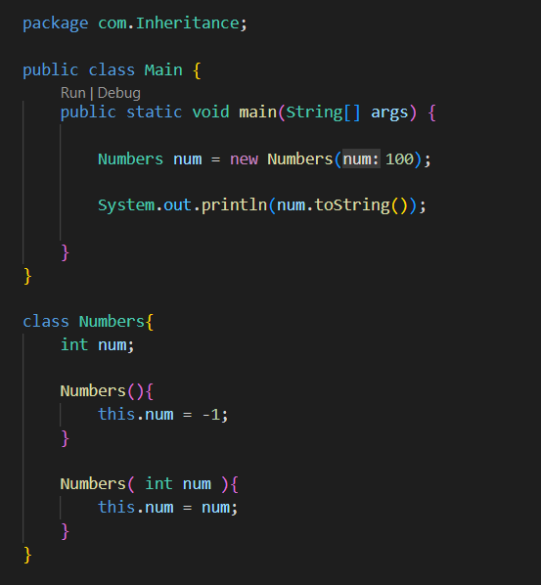

In java every classes that we create are inheriting the Object class

This all happens internally in java

And this toString( ) function is defined in that Object class

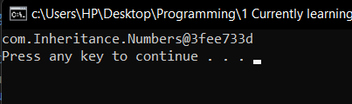

Output is some random stuffs, looks like hashes

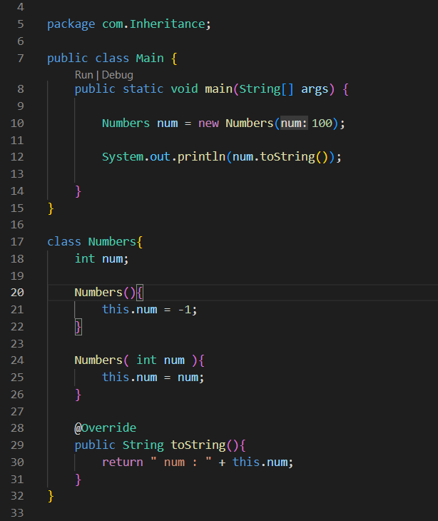

Here we define our own toString( ) method in the Numbers class

So the toString( ) method of the Object class is overridden

